User Guide for
NCP81074
Open Loop Evaluation Board

This user guide is intended to assist those using the NCP81074 Open Loop Evaluation Board. It will provide useful tips and procedures for powering up and using the Evaluation Board (EVB). It is intended as a quick-start guide rather than a comprehensive manual.
Description
The NCP81074 is a single channel, low−side MOSFET driver. It is capable of providing large peak currents into capacitive loads. This driver can deliver a 7 A peak current at the Miller plateau region to help reduce the Miller effect during MOSFETs switching transitions. It exhibits a split output configuration allowing the user to control the turn on and turn off slew rates.
Features
- High Current Drive Capability ±10 A
- TTL/CMOS Compatible Inputs Independent of Supply Voltage
- High Reverse Current Capability (10 A) Peak
- 4 ns Typical Rise and 4 ns Typical Fall Times with 1.8 nF Load
- Fast Propagation Delay Times of 15 ns with Input Falling and 15 ns with Input Rising
- Input Voltage Range from 4.5 V to 20 V
- Split Output Configuration
- Dual Input Design Offering Drive Flexibility
- These Devices are Pb−Free, Halogen Free/BFR Free and are RoHS Compliant
Quick Start Connection Guide
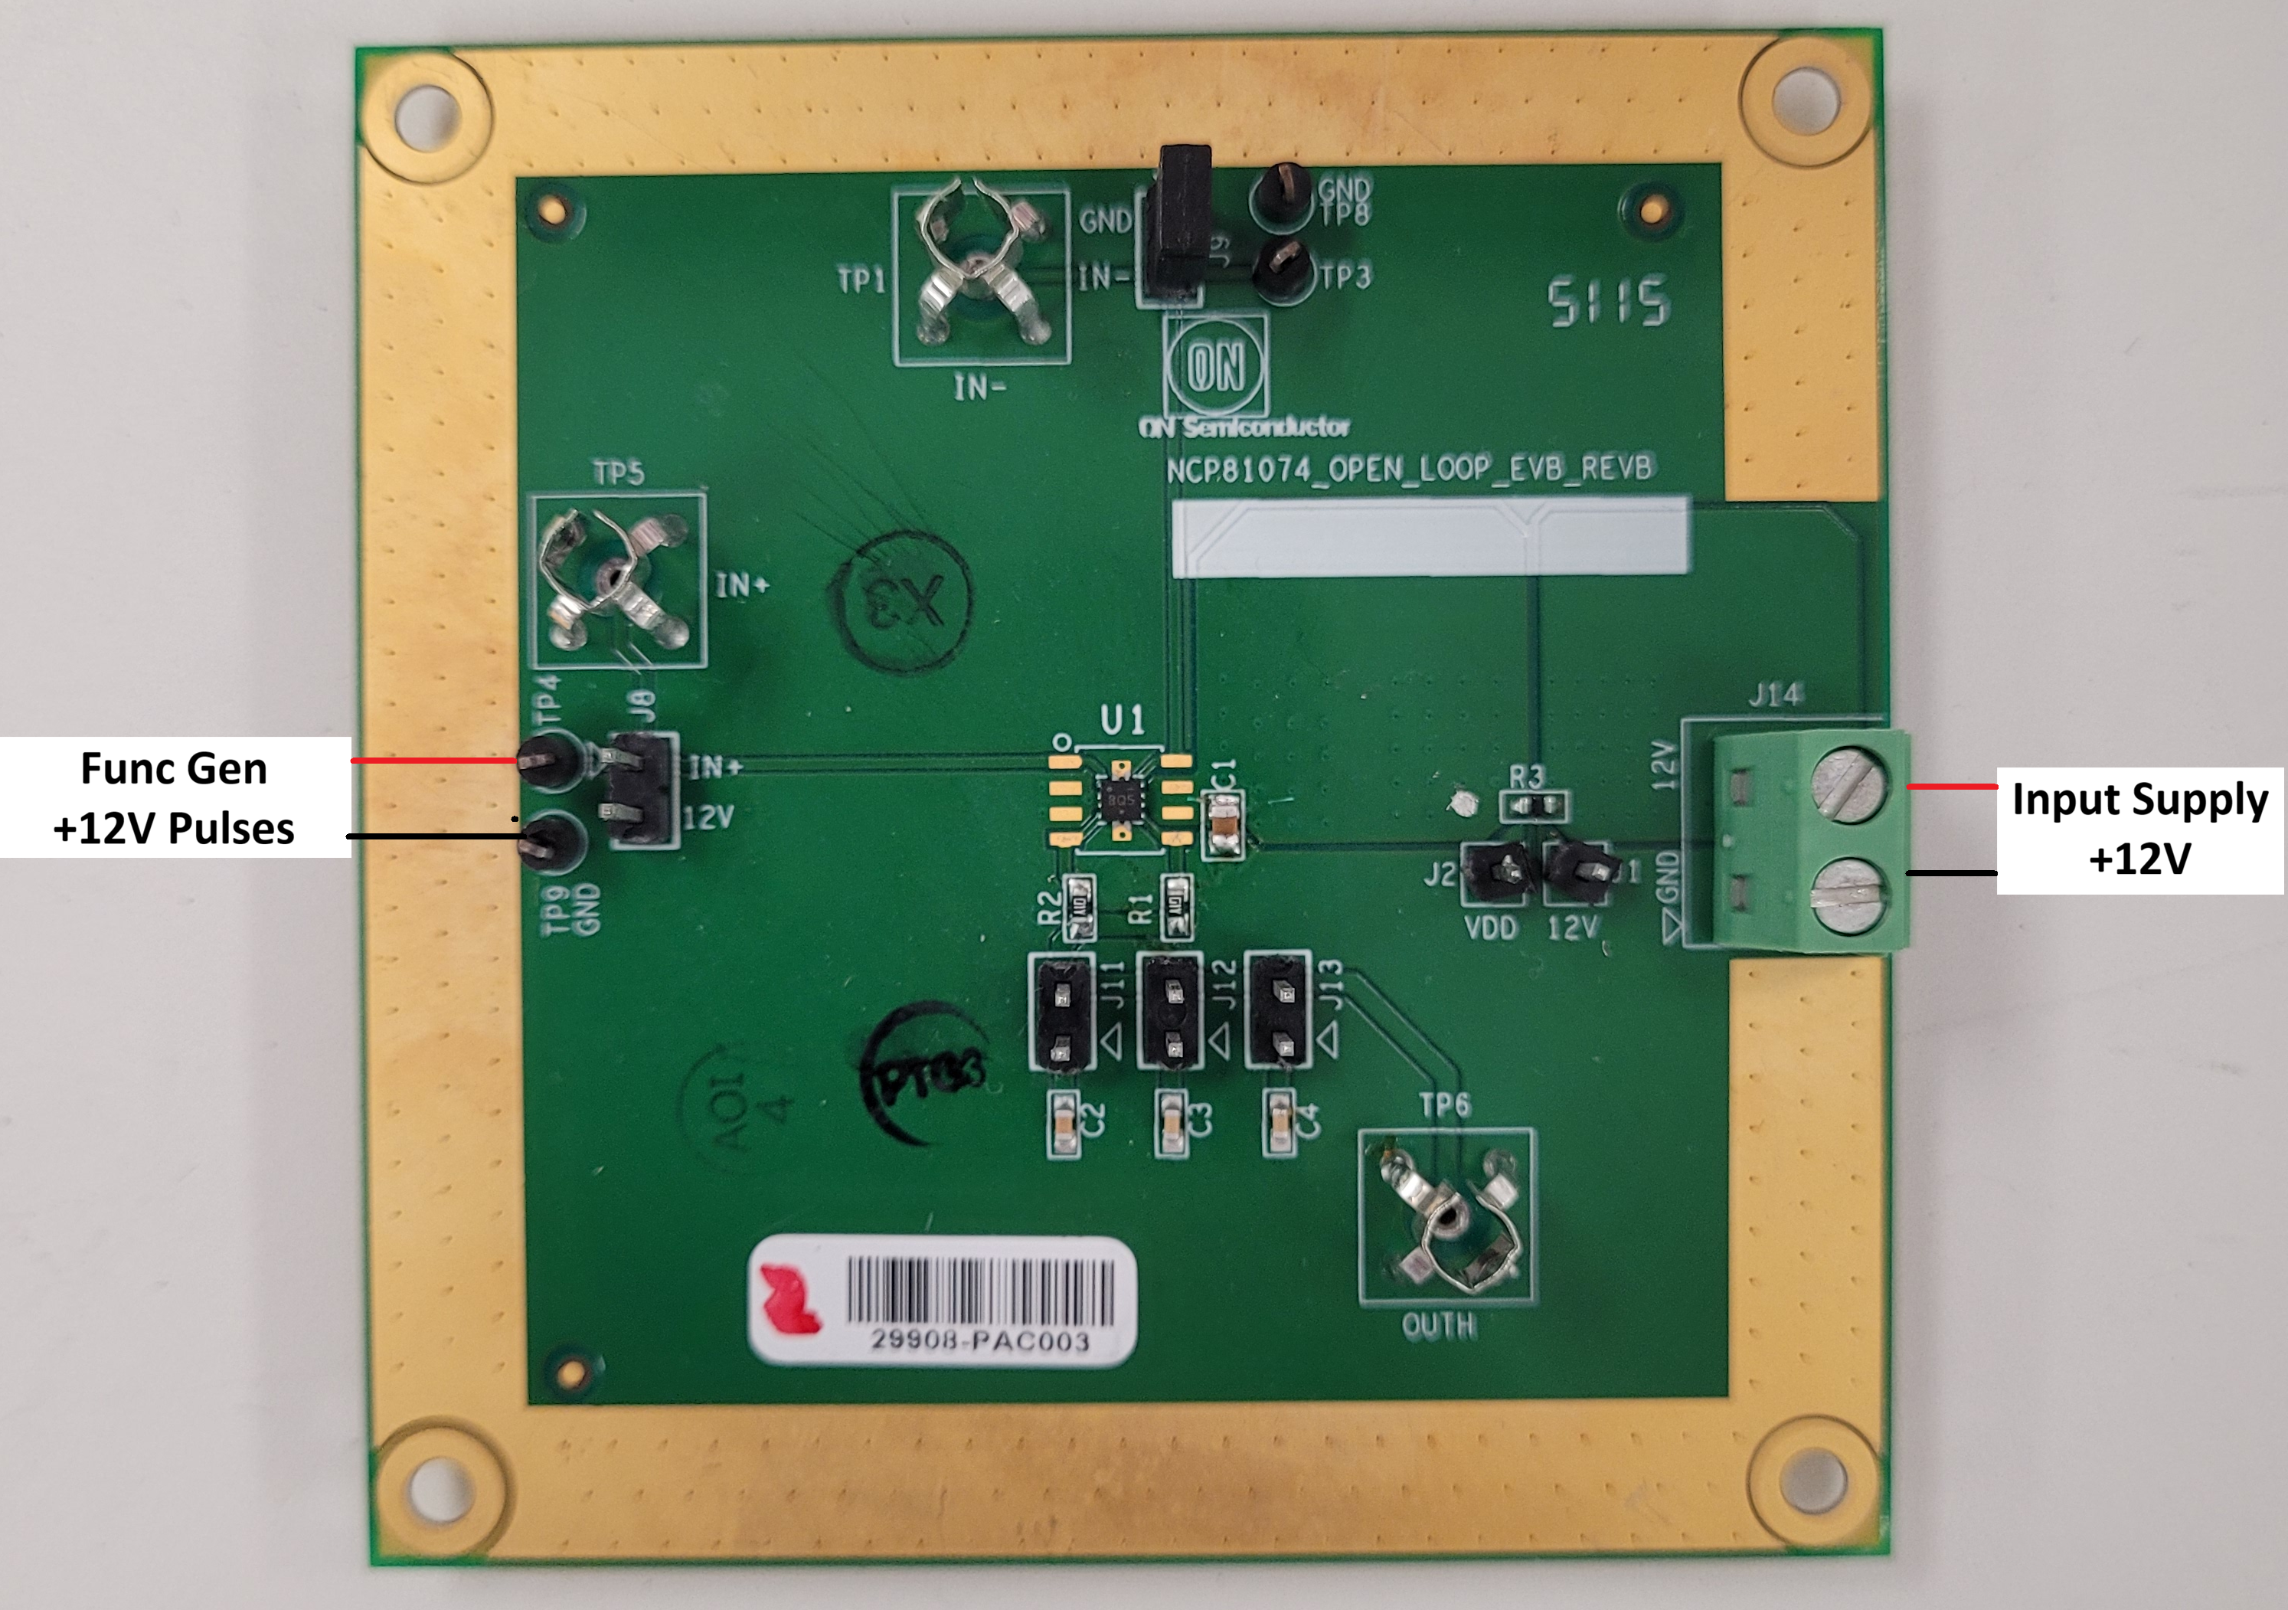

Connect a power supply capable of 20V and 1A+ to the Input Supply connector J14 (+ to 12V, - to GND), set the input supply voltage to 12V and the current limit to 1A. Connect a function generator, positive end to TP4 and negative to TP9. Setup the function generator to output a square wave, amplitude from 0 to 12V, switching frequency at 10kHz. Turn on the input power supply, then the function generator output. Probe TP5 to see if the output of the driver matches the input square wave.

